**New Zealand Diploma in Information Systems**

**HTCS5607 IS Application Project**

**TECHNICAL REPORT TEMPLATE**

**Project Name:**

|  |  |  |  |
| --- | --- | --- | --- |
| **Project Team Name(s)** | **Student ID** | **Email** | **Phone** |
| ***Project Manager***  *Jason Down* | 1548373 |  |  |

**Client Stakeholders**

|  |  |  |
| --- | --- | --- |
| **Client Stakeholders** | **Full name and title** | **Contact details** |
| **Project Sponsor(s)** | *Lei Song, Simon Dacey* |  |
| ***Balham College*** |  |  |

**DATE OF SUBMISSION**

*dd/mm/yyyy*

Table of Contents

1. Document Control 4

1.1 Version History 4

1.2 Contribution to Report sections 4

1.3 Glossary 4

2. Executive Summary 5

3. Introduction 6

4. Technology Review 7

5. IT Methodology 8

6. Project Management 9

6.1 Project Management Narrative 9

6.2 Project Plan with Milestones 9

6.3 Project Governance Responsibilities 9

6.4 Project Meetings 9

6.5 Project Reports 9

6.6 Project Risk and Issue Analysis 9

7. Requirements Analysis 10

7.1 Introduction 10

7.2 Use Case Diagram 10

7.3 Business Use Case Narratives (Descriptions) 10

7.4 Activity Diagrams 10

7.5 Overall Class Diagram 10

8. Project Design 11

8.1 Introduction 11

8.2 Software List 11

8.3 Version Control Software 11

8.4 Design Use Case Narratives (Descriptions) 11

8.5 Sequence Diagrams 11

8.6 Deployment Diagram 11

8.7 Database Design 11

8.8 Annotated User Interface Designs 11

8.9 Test Plan 11

9. Project Training 12

9.1 End User Background and Training Objectives 12

9.2 Training Materials 12

9.3 Training Deliverables 12

9.4 Evaluation 12

10. Conclusion & Lessons Learned 13

References 14

Appendices 15

# 1. Document Control

## 1.1 Version History

This document has had the following revisions:

| **Version** | **Date** | **Author** | **Description of Change** |
| --- | --- | --- | --- |
| 0.1 | 26/08/2021 | Jason Down | Initial draft |

## 1.2 Contribution to Report sections

| **Project Team Member name** | **Student ID** | **Report Section** |
| --- | --- | --- |
| Jason Down | 1548373 | Everything |

## 1.3 Glossary

To provide clarity, terms and acronyms used in this document are defined as follows:

| **Term / Abbreviation** | **Definition** |
| --- | --- |
| Supervisor | Technical Advisor |
|  |  |

# 2. Executive Summary

# 3. Introduction

Balham College is an educational organization that needs an information system to manage its students, their enrolments, their courses and their programmes. At the current phase of development, only the systems which manage the courses and programmes are required. In this technical report, the planning, initialization, design, development, and launch, along with training and deployment are covered in extensive detail. This report will cover the decision making, and the steps used in the creation of the product. The final product, including all code and testing results, will not be in this document.

# 4. Technology Review

The project that we are tasked with creating will require a user interface and data storage, it will need to be written in a programming language and interact with a database of some kind to manage the courses and programmes of Balham College. The project will be interacted with using a web application (Using HTML, CSS and Bootstrap CSS), meaning it can run on a large selection of devices, and does not require the user to manage or download software. The following section will cover the decision making and reasoning of our chosen language, database, and IDE (more on that later).

The first piece of technology we will choose and the most important, is the programming language. Not only can the programming language we choose determine the difficulty to code the program, but it can also determine the overall functionality of the software, such as what database and IDE we can use. Some of the most popular languages we can choose from include C#, JavaScript, Python, Java, and Go. C# is an object oriented, class-based programming language, commonly paired with the .NET framework, a set of libraries that can be run on many types of information systems, such as IOT devices, watches, phones and many operating systems. C# and .NET are developed by Microsoft. C# however is very complicated to use, is rather outdated, and for our application, its speed is not necessary. JavaScript was “initially developed to be used as a client-side scripting language for dynamic web pages” but is now used on server-side applications using runtimes such as Node.js, (Kanchev, 2021). JavaScript is scalable, fast and popular but is harder to master than other languages. For our use case, we don’t need our program to be scalable, and don’t need the speed. Python is an object oriented, high-level programming language designed for rapid development and ease of use, it is very beginner friendly, has an extensive list of libraries from web development (Flask, Django), database interfacing (SQLite, MySQL) to game creation (PyGame, PyKyra) and machine learning (Keras, PyTorch, Tensorflow). Python suffers from performance, but its pros outweigh its cons in our project. Go is a programming language designed to replace languages like C++ with its speed and simplicity. Go is mostly used in server-side applications; however, it is rather new, and many issues one may have learning won’t have been solved, resulting in longer development times. The 2 languages that seem the most relevant for the type of application we are making (a web application) are JavaScript (using some sort of server-side engine) and Python (using an http server library like Flask). Due to the simplicity of Python, and its wide application, we will choose it for our project, along with the Flask library for web development.

The IDE or Integrated Development Environment is the next utility we must choose for our project. An IDE is essentially a text editor, though designed for developers to write better code faster, with all the tools they need in one place. Some integrated development environments are designed to support many different languages, while others are tailored to individual languages. For our selected programming language (Python) there is a handful of integrated development environments to choose from: PyCharm, Visual Studio, Sublime, or the Python IDE. PyCharm is an IDE developed by JetBrains. IntelliJ and many other IDEs are created by JetBrains; PyCharm is a Python IDE tailored to the language specifically, it has code completion, error highlighting and many other features such as integration with popular frameworks (Flask, Django). PyCharm would be ideal as it is tailored for Python, and its error highlighting and code completion will greatly assist in development speed. Visual Studio is another IDE, popular for its .NET forum creator and its vast support for many languages such as C++, C#, JavaScript and many others. Visual Studio has very powerful code completion, though its interface is very complicated, and its capabilities far exceed our requirements, making it very sluggish in terms of performance. These cons make Visual Studio very hard to master. Sublime text is more of a text editor with syntax highlighting rather than an IDE. It features code completion, albeit only containing previously declared variables and functions. It features very primitive error highlighting, and while it has some integrations with Python (console output, build shortcuts) it is not ideal for a large project such as a web application. The Python IDE otherwise known as ‘IDLE’ is a Python specific integrated development environment that comes with the default installation of Python. It features the same syntax highlighting of any IDE, console output and error messages, though it has a very outdated appearance, has no code completion and weak error highlighting. For the requirements of our IT project, PyCharm IDE is a good fit for our requirements. It’s simple, easy to learn interface, in conjunction with its efficient code completion and error highlighting make it perfect for our project.

Databases have many implementations. Databases supported by Python that suite our application consist of SQL implementations. SQL or ‘Structured Query Language’ is a standard for relational databases. Microsoft Access is a database management system that only functions on Windows, though since we are using a web application this technically isn’t important. The databases graphical user interface (GUI) makes it very easy to create tables and their relations, however Access is rather outdated, and its limitation to Windows operating systems, as well as it being part of the Office suite of applications makes it costly and hard to deploy in the future. SQLite is a small and reliable database engine already included in most devices such as mobile phones, it is bundled in the default installation of Python, and its very easy to learn. SQLite is not proficient in handling multiple users, meaning it is not suitable for large websites, however in our instance of a web application used to manage a school, it is highly unlikely that our application will fall into the hands of a wider audience. MySQL is another SQL implementation that is multithreaded compared to SQLite. This approach means that MySQL can be used for many users, which is not necessary for our product. Due to Python already having SQLite built in, its simplicity, wide use and intuitive learning, it is a good choice for our IT project.

# 5. IT Methodology

# 6. Project Management

## 6.1 Project Management Narrative

*Details with evidence how the development of the project followed the selected systems development lifecycle*

## 6.2 Project Plan with Milestones

*Include an overall plan here and attach a detailed GANTT chart to the appendices*

## 6.3 Project Governance Responsibilities

*Explain who was responsible for project management and quality assurance, and explain how these tasks were carried out*

## 6.4 Project Meetings

*Include a schedule of your meetings (date, duration, participants, and type) and attach the minutes of each meeting to the appendices*

## 6.5 Project Reports

*Discuss the project status reports and attach your project status reports to the appendices*

## 6.6 Project Risk and Issue Analysis

*Discuss project risks and issues and attach your project risk and issue register to the appendices*

# 7. Requirements Analysis

## 7.1 Introduction

## 7.2 Use Case Diagram

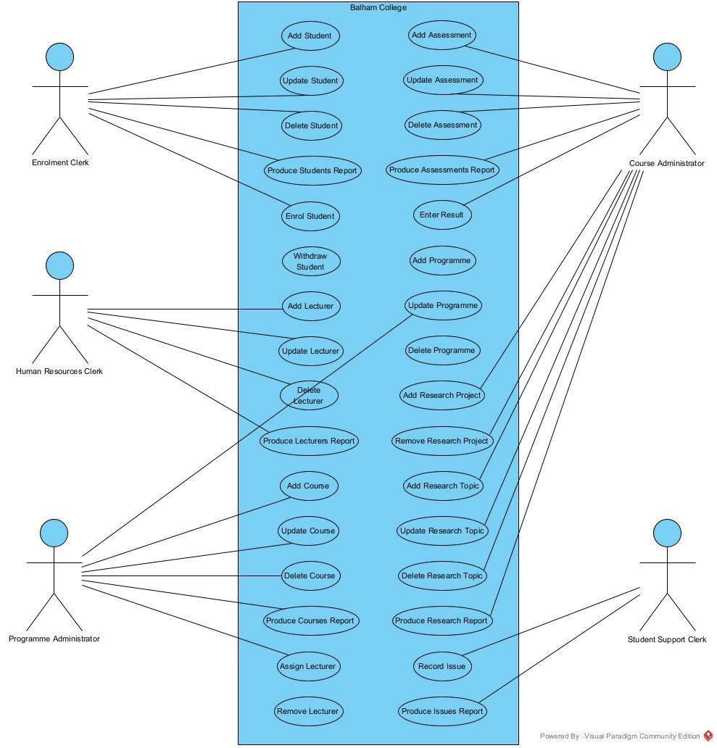

## 7.3 Business Use Case Narratives (Descriptions)

1. Add Course

Use Case ID: 11

Description: This use case enables the programme administrator to add a course’s details.

Priority: High

Pre-conditions: The programme administrator has logged onto the system

Post Conditions: None

Assumptions: None

* The programme administrator selects the “Add Course” function.
* The system displays the “Add Course” form with all fields blank.
* The programme administrator enters the course’s details (course id (1 to 9999 inclusive), course name, credits (5 to 120 inclusive), fee (200.00 to 8000.00 inclusive), and status (current or suspended)).
* The system either confirms that the details are filled in correctly or identifies that the details are missing or incorrect and prompts for the completion of the details.
* The system displays a list of programmes (programme name and level).
* The programme administrator selects a programme.
* The programme administrator either elects to add the course or elects to cancel the operation and the system closes the form.
* The system saves the course’s details (course id, course name, credits, status, and programme).
* The system displays the “Course added successfully” message.
* The system displays the “Add another course?” prompt.
* The programme administrator either elects to end the use case and the system closes the form, or elects to add another course and the system displays the “Add Course” form with all fields blank.

1. Update Course

Use Case ID: 12

Description: This use case enables the programme administrator to update a course’s details.

Priority: High

Pre-conditions: The programme administrator has logged onto the system

Post Conditions: None

Assumptions: None

* The programme administrator selects the “Update Course” function.
* The system displays the “Update Course” form and displays a list of all the courses (course id and course name).
* The programme administrator either selects the course that has details that needs updating or elects to cancel the operation and the system closes the form.
* The system displays the course’s details (course id, course name, credits, status, fee, and programme name).
* The programme administrator updates the relevant details (name, credits, fee, and status only).
* The system validates the entries in the fields and either prompts for confirmation to change the courses details or identifies missing or incorrect fields and prompts for completion of the entry.
* The programme administrator either confirms the change of details or cancels the changes and the system closes the form.
* The system saves the course’s details.
* The system displays the “Course updated successfully” message.
* The system displays the “Update another course?” prompt.
* The programme administrator either elects to end the use case and the system closes the form, or elects to update another course and the system displays the “Update Course” form and displays a list of all the courses (course id and course name).

1. Delete Course

Use Case ID: 13

Description: This use case enables the programme administrator to delete a course’s details.

Priority: High

Pre-conditions: The programme administrator has logged onto the system

Post Conditions: None

Assumptions: None

* The programme administrator selects the “Delete Course” function.
* The system displays the “Delete Course” form and displays a list of all the courses (course id and course name) that have no lecturers, assessments, or enrolments assigned to them.
* The programme administrator either selects the course that requires deleting or elects to cancel the operation and the system closes the form.
* The system displays the course’s details (course id, course name, credits, and status).
* The programme administrator either elects to delete the course or elects to cancel the operation and the system closes the form.
* The system deletes the course.
* The system displays the “Course deleted successfully” message.
* The system displays the “Delete another course?” prompt.
* The programme administrator either elects to end the use case and the system closes the form, or elects to delete another course and the system displays the “Delete Course” form and displays a list of all the courses (course id and name) that have no lecturers, assessments, or enrolments assigned to them.

1. Produce Courses Report

Use Case ID: 14

Description: This use case enables the programme administrator to produce the courses report.

Priority: High

Pre-conditions: The programme administrator has logged onto the system

Post Conditions: None

Assumptions: None

* The programme administrator selects the “Courses Report” function.
* The system displays the “Courses Report” form.
* The programme administrator either selects the option to generate the report or elects to cancel without generating the report and the system closes the form.
* The system gets the details (course ID, course name, credits, status, fee, and programme name) of each course.
* The system counts the number of enrolments for each course.
* The system counts the number of assessments for each course.
* The system then generates the courses report (course ID, course name, credits, status, and programme name) with the course sorted by name.
* The system concludes the use case by closing the form.

1. Enter Result

Use Case ID: 21

Description: This use case enables the course administrator to enter a result for a student against an assessment.

Priority: High

Pre-conditions: The course administrator has logged onto the system

Post Conditions: None

Assumptions: None

* The course administrator selects the “Enter Result” function.
* The system displays the “Enter Result” form and displays a list of all assessments (assessment id, assessment number, assessment name and course name).
* The course administrator either selects the assessment that is to be assigned or elects to cancel the operation and the system closes the form.
* The system displays the assessment’s details (assessment number, assessment name, maximum mark, and course name) and then displays a list of all enrolments (student name, year, semester, and status) for the course of the selected assessment.
* The course administrator either selects an enrolment and enters a mark (0 to 200 inclusive) and a result date or elects to cancel the operation and the system closes the form.
* The system saves the result (assessment, enrolment, result date, and mark) unless a result has already been entered for assessment and enrolment in which an error message is displayed.
* The system displays the “Result entered successfully” message.
* The system displays the “Enter another result?” prompt.
* The course administrator either elects to end the use case and the system closes the form, or elects to enter another result and the system displays the “Enter Result” form and displays a list of all assessments (assessment id, assessment number, assessment name and course name).

1. Add Programme

Use Case ID: 22

Description: This use case enables the programme administrator to add a programme’s details.

Priority: High

Pre-conditions: The programme administrator has logged onto the system

Post Conditions: None

Assumptions: None

* The programme administrator selects the “Add Programme” function.
* The system displays the “Add Programme” form with all fields blank.
* The programme administrator enters the programme’s details (programme id (1 to 50 inclusive), programme name and level (1 to 10 inclusive).
* The system either confirms that the details are filled in correctly or identifies that the details are missing or incorrect and prompts for the completion of the details.
* The programme administrator either elects to add the programme or elects to cancel the operation and the system closes the form.
* The system saves the programme’s details (programme id, programme name, and level).
* The system displays the “Programme added successfully” message.
* The system displays the “Add another programme?” prompt.
* The programme administrator either elects to end the use case and the system closes the form, or elects to add another programme and the system displays the “Add Programme” form with all fields blank.

1. Update Programme

Use Case ID: 23

Description: This use case enables the programme administrator to update a programme’s details.

Priority: High

Pre-conditions: The programme administrator has logged onto the system

Post Conditions: None

Assumptions: None

* The programme administrator selects the “Update Programme” function.
* The system displays the “Update Programme” form and displays a list of all the programmes (programme id and programme name).
* The programme administrator either selects the programme that has details that needs updating or elects to cancel the operation and the system closes the form.
* The system displays the programme’s details (programme id, programme name, and level).
* The programme administrator updates the relevant details (programme name and level only).
* The system validates the entries in the fields and either prompts for confirmation to change the programmes details or identifies missing or incorrect fields and prompts for completion of the entry.
* The programme administrator either confirms the change of details or cancels the changes and the system closes the form.
* The system saves the programme’s details.
* The system displays the “Programme updated successfully” message.
* The system displays the “Update another programme?” prompt.
* The programme administrator either elects to end the use case and the system closes the form, or elects to update another programme and the system displays the “Update Programme” form and displays a list of all the programmes (programme id and programme name).

1. Delete Programme

Use Case ID: 24

Description: This use case enables the programme administrator to delete a programme’s details.

Priority: High

Pre-conditions: The programme administrator has logged onto the system

Post Conditions: None

Assumptions: None

* The programme administrator selects the “Delete Programme” function.
* The system displays the “Delete Programme” form and displays a list of all the programmes (programme id and programme name) that have no courses assigned to them.
* The programme administrator either selects the programme that requires deleting or elects to cancel the operation and the system closes the form.
* The system displays the programme’s details (programme id, programme name, and level).
* The programme administrator either elects to delete the programme or elects to cancel the operation and the system closes the form.
* The system deletes the programme.
* The system displays the “Programme deleted successfully” message.
* The system displays the “Delete another programme?” prompt.
* The programme administrator either elects to end the use case and the system closes the form, or elects to delete another programme and the system displays the “Delete Programme” form and displays a list of all the programmes (programme id and name) that have no courses assigned to them.

## 7.4 Activity Diagrams

## 7.5 Overall Class Diagram

# 8. Project Design

## 8.1 Introduction

## 8.2 Software List

## 8.3 Version Control Software

## 8.4 Design Use Case Narratives (Descriptions)

## 8.5 Sequence Diagrams

## 8.6 Deployment Diagram

## 8.7 Database Design

*Include ERD and data dictionary*

## 8.8 Annotated User Interface Designs

## 8.9 Test Plan

# 9. Project Training

## 9.1 End User Background and Training Objectives

## 9.2 Training Materials

## 9.3 Training Deliverables

## 9.4 Evaluation

# 10. Conclusion & Lessons Learned

# References

Kanchev, K. (2021), 10 Interesting Facts About JavaScript Each JS Programmer May Want to Know. *Techva Me,* [*https://techva.me/ten-interesting-facts-about-javascript/*](https://techva.me/ten-interesting-facts-about-javascript/)

# Appendices